

**DATA SCIENCE BATCH-2023**

**Büşra Osmanoğlu**

**OGTIPDSBO037**

The following commands were written and run in the Python Console in PyCharm.

1. Adding Two Numbers



1. Maximum of Two Numbers



1. Factorial of a Number

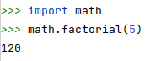

1. Function for Simple Interest

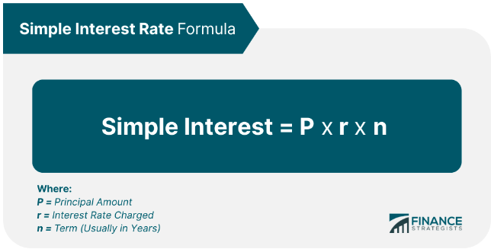

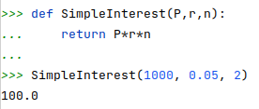

1. Function for Compound Interest

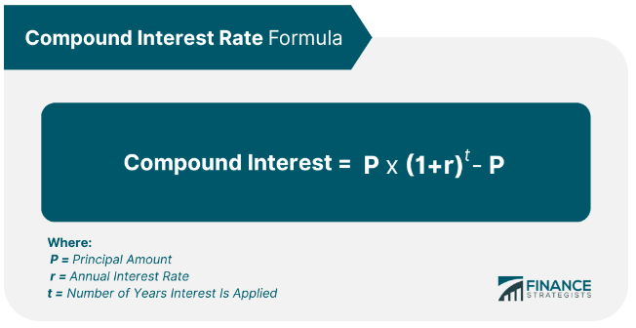

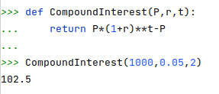

1. Check Armstrong Number

Examples: 153 = 13 + 53 + 33

93084 = 95 + 35 + 05+ 85 + 45

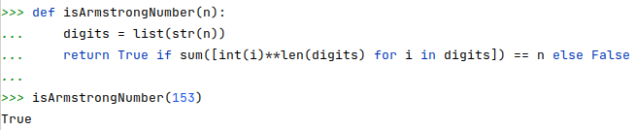

1. Function for Area of a Circle

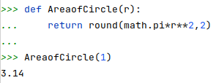

* Positive Divisors Except 1 and n

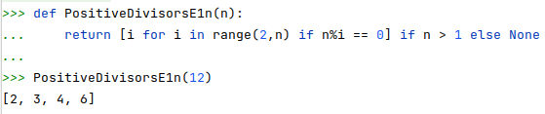

1. All Prime Numbers in an Interval by using *PositiveDivisorsE1n* function above

1. Check If a Number Prime or Not by using *PositiveDivisorsE1n* function

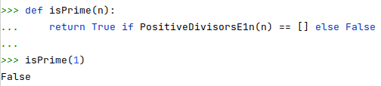

1. n-th Fibonacci Number

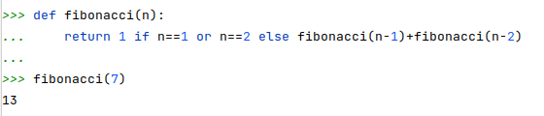

1. Function Checking If a Number is a Fibonacci Number by using *fibonacci* function (10)

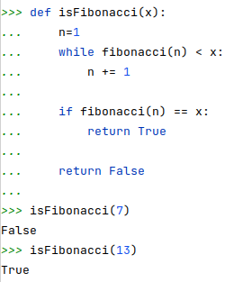

1. mth Multiple of a number in Fibonacci Series by using *fibonacci* function (10)

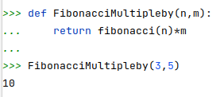

1. ASCII Value of a Character



1. Sum Of Squares of First n Natural Numbers

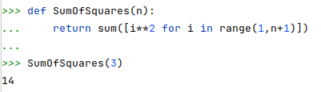

1. Cube Some of First n Natural Numbers

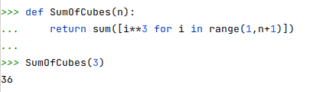

**SOURCES**

* https://www.financestrategists.com/banking/interest-rate/?gclid=Cj0KCQjw6cKiBhD5ARIsAKXUdyZKeqX5hhJtI9egJK2w90nP0wkS7v_PEpbmknFuhqAqX5-bkiuTjBoaAgucEALw_wcB